## **SDLC and Mobile Apps**

The Software Development Life Cycle (SDLC) is a systematic approach for every step of the software application process including planning, designing, developing, testing, and deploying. Mobile application development is one of the areas where S D L C is most utilized and thus guarantees an app to be user-friendly, reliable over a variety of devices, and the whole process of app delivery being efficient. The phases of mobile SDLC are generally adjusted to meet the challenges that are specific to the platform such as small screen size, different hardware capabilities, and constant changes in operating systems.

1. **Requirements Analysis**

The very first phase is the analysis of requirements, where software developers work together with various parties to set the goals of mobile apps. The workflow involves not only specifying functional requirements like user registration, push notifications, GPS access, and offline usage but also non-functional requirements such as performance, security, and battery efficiency. Moreover, the decisions concerning target platforms (Android, iOS, or cross-platform) and the intended audience have also been finalized during this stage. If the requirements are explicitly stated, they will help in darting misunderstandings in the future and will also drive out the scope creep.

1. **Design Phase**

Then comes the design phase where requirements are made into precise specifications for the design. Special focus is given to UI/UX design to make sure that it is easy to use on small touch-based screens, in the case of mobile apps. Wireframes, navigation flows, and layouts are produced as well as the technical designs dealing with system architecture, databases, APIs, and device integrations. Good implementation of a design ensures better scalability and easier maintenance in the future.

1. **Implementation Phase**

The phase of implementation requires the development of the application with the appropriate technologies for the corresponding platforms, for instance, getting Android done in Kotlin, iOS in Swift, or using cross-platform frameworks such as Flutter. The feature development goes according to the design and additionally, the features are linked up with the backend services by the use of version control systems.

1. **Testing Phase**

The application, once created, is subjected to testing that includes a whole range of tests: functional, performance, usability, and security. These tests are done on several different devices at the same time in order to locate bugs and thus assure the reliability of the product.

1. **Deployment Phase**

Finally, the application goes through the deployment stage where it is first processed and then made accessible to the users through the app stores like Google Play or the App Store. (testdevlab, 2026)

## **Specification and Design**

The specification and design phase determines what features the Fitness Tracking App will include and how it will operate, ensuring that user needs, usability principles, and technical practicalities are taken into account. Then, a clear, user-centric mobile application is created using the most appropriate specification and design methods.

User Requirements Specification

The user requirements, determined with a user-centered approach, targeted fitness app end-users including beginners and regular users.

basic structure such input data requirements

Fitness tracker applications even collect fitness-related input from users during registration. The home page allows users to enter their goals. The activity page and workout page also display relevant inputs and basic information.

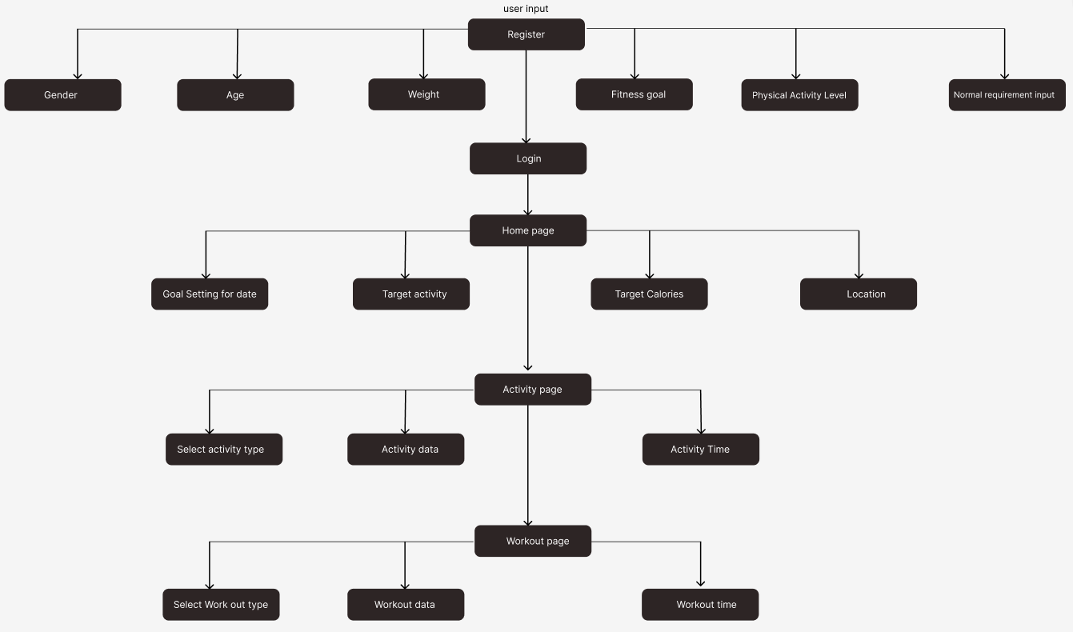

Figure 3.1

system architecture and wireframes

Welcome screen

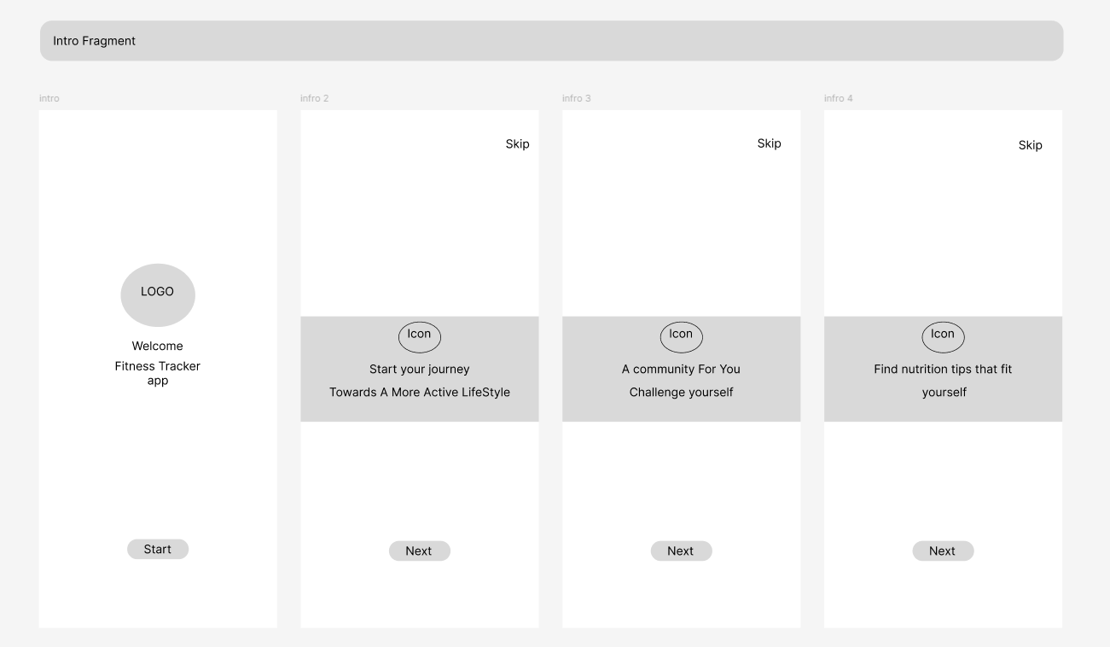

Figure 3.2

Register and login

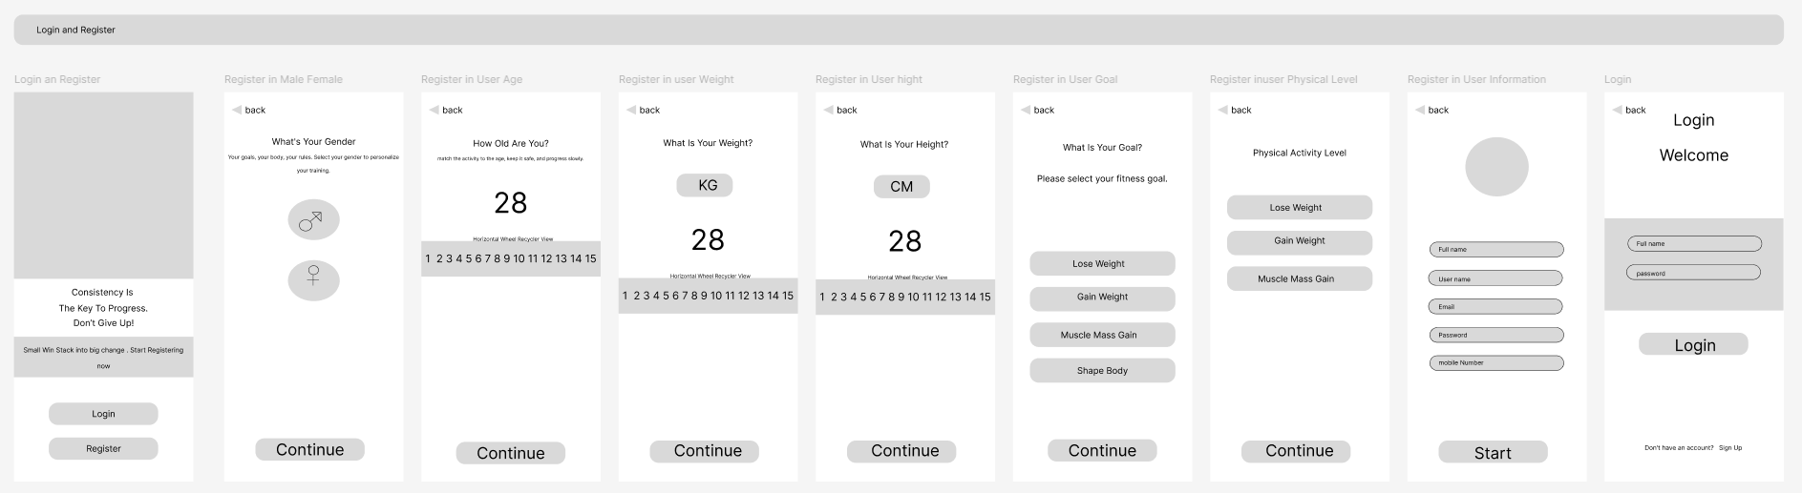

Figure 3.3

Goal setting, activity and workout screen

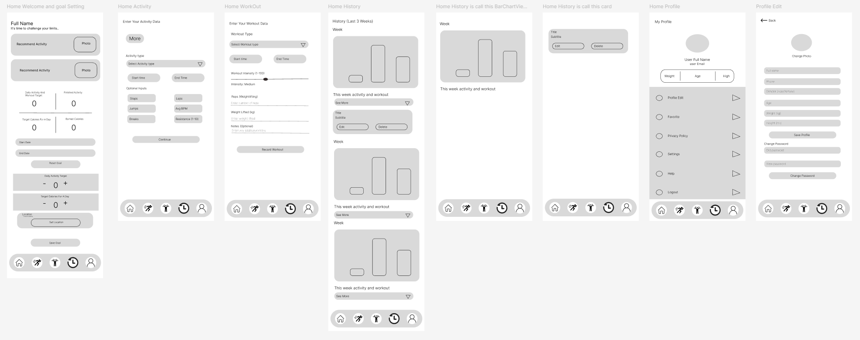

Figure 3.4

Interaction flows

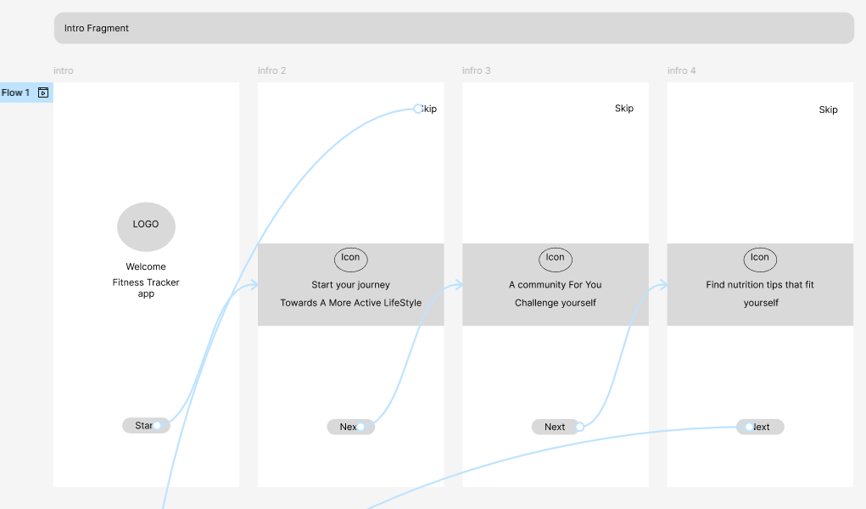

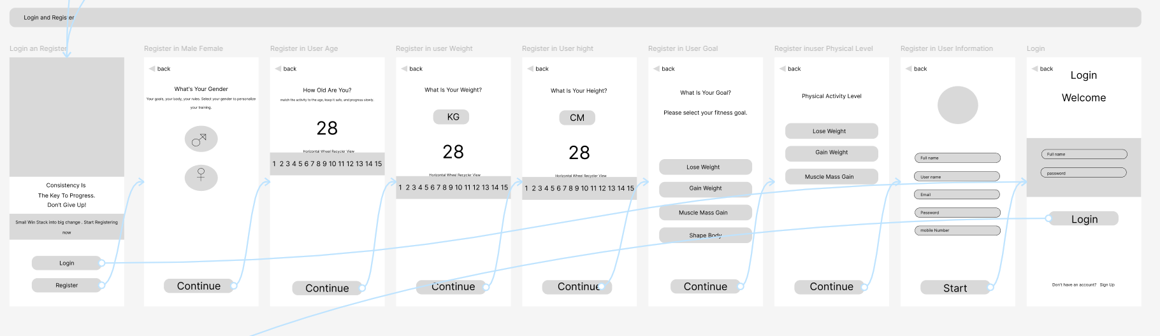

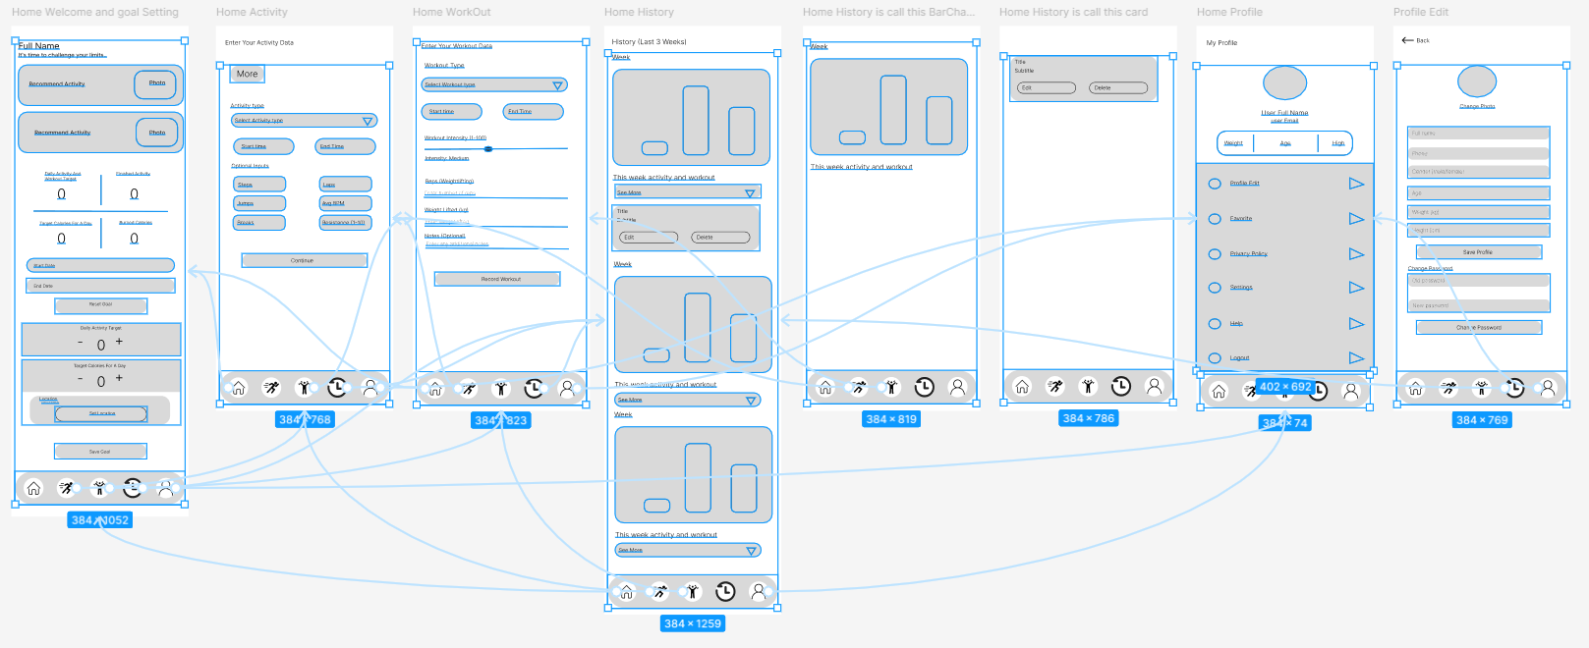

# Task 4: Developing Application Functionality

Using Android Studio

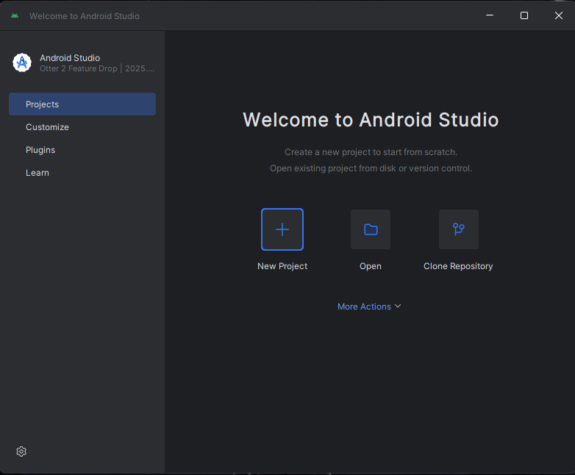

FIGURE-4.1

Use android studio with start project

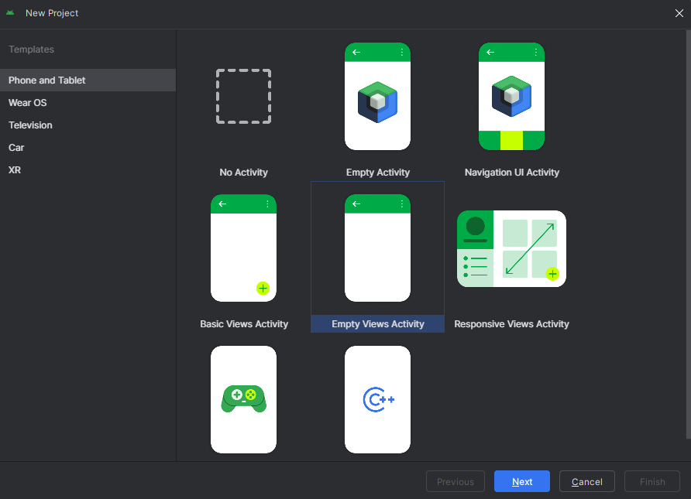

FIGURE-4.2

Empty view activity with new project

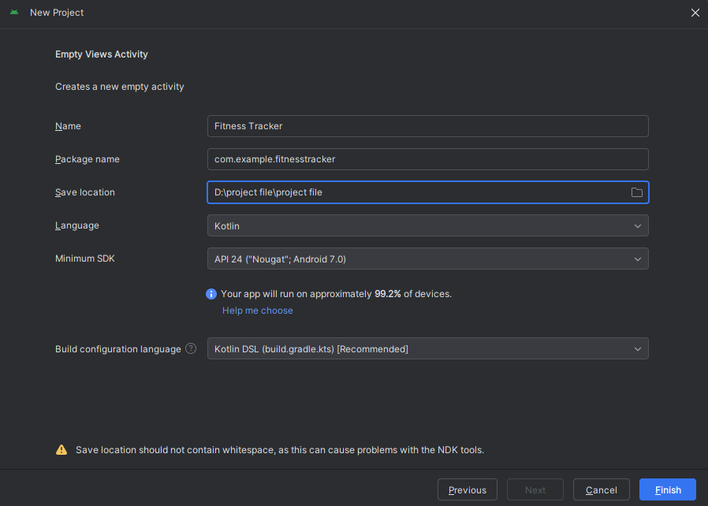

FIGURE-4.3

Fitness Tracker project start

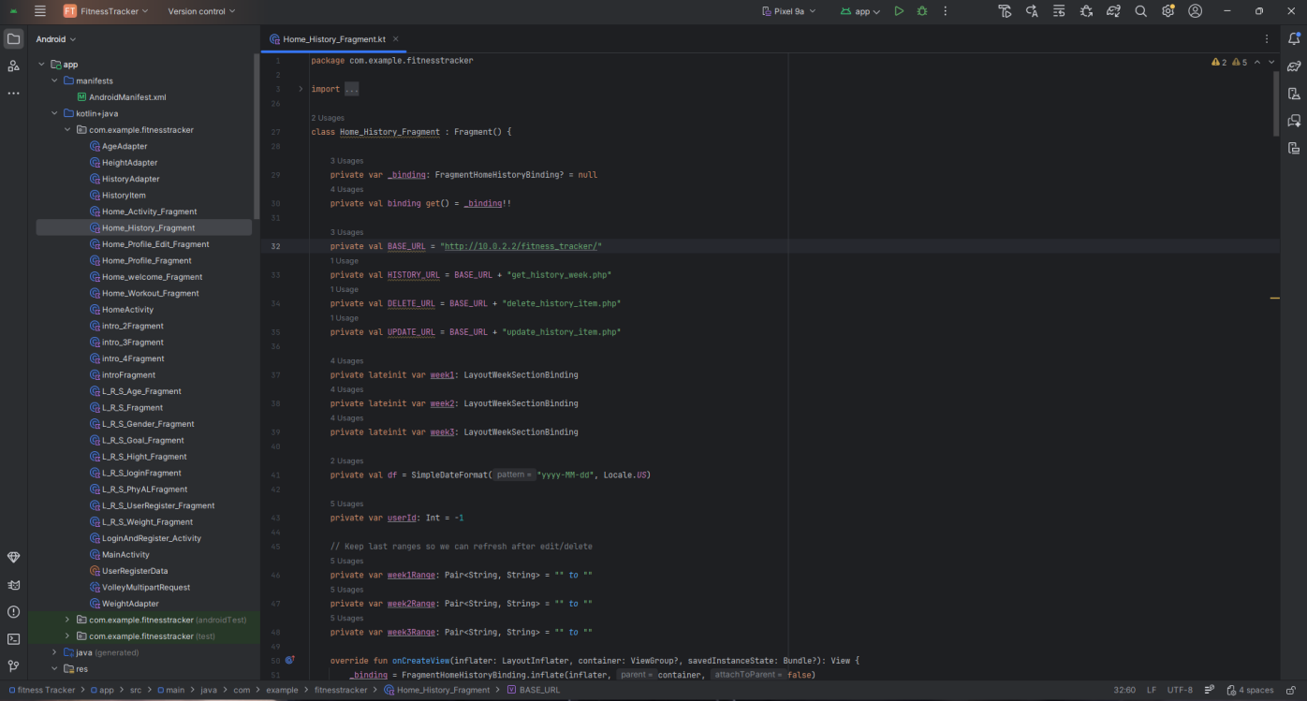

FIGURE-4.4

Kotlin Program

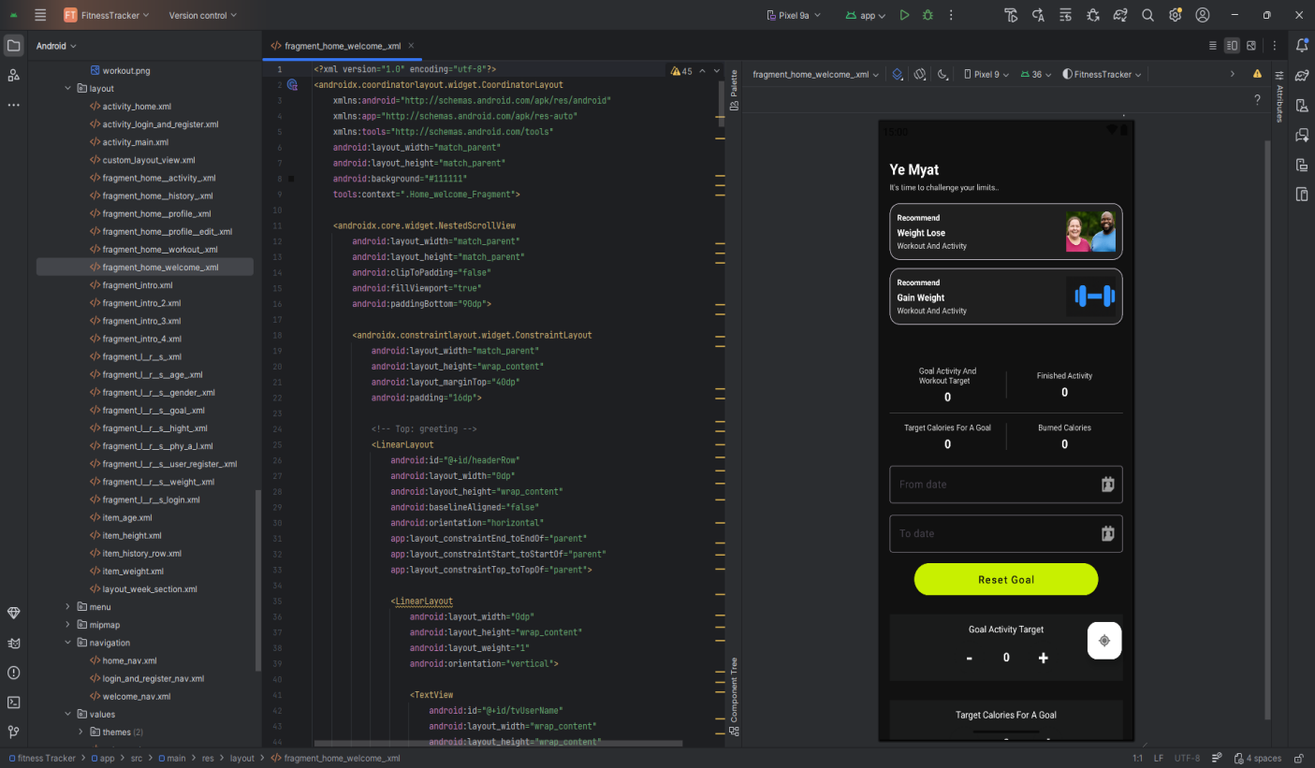

FIGURE-4.5

Home Welcome Layout

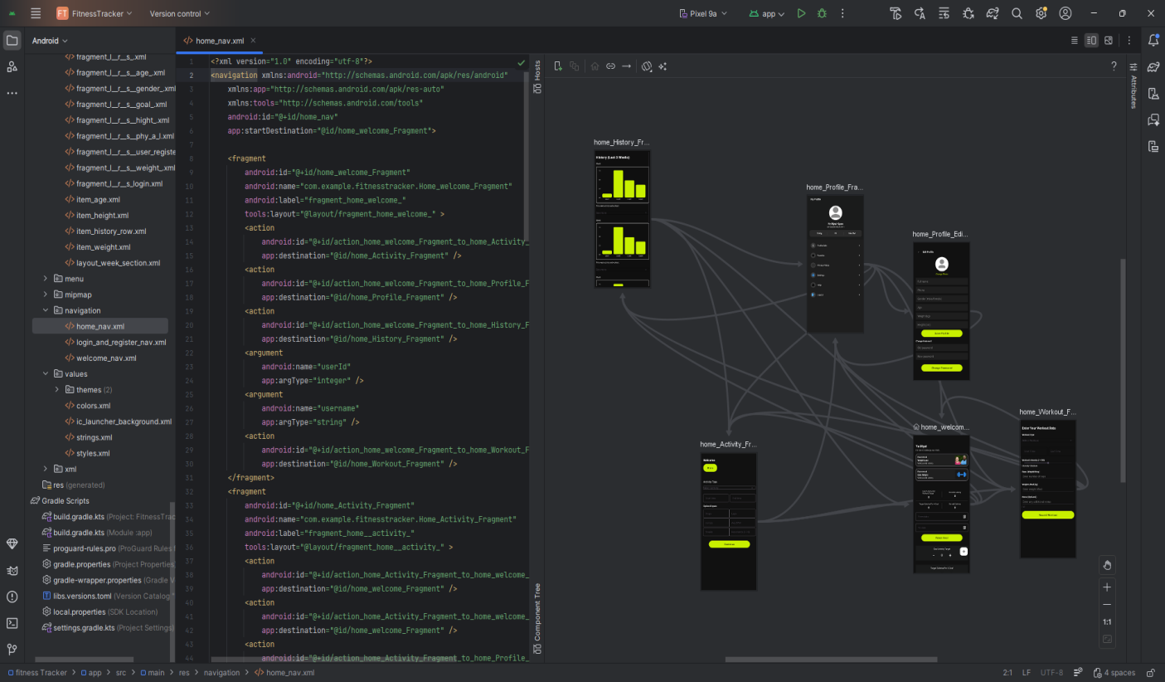

FIGURE-4.6

Home screen Navigation

## User Interface Elements

|  |  |
| --- | --- |
| FIGURE-4.7 | FIGURE-4.8 |
| FIGURE-4.9 | FIGURE-4.10 |

|  |  |
| --- | --- |
| FIGURE-4.11 | FIGURE-4.12 |
| FIGURE-4.13 | FIGURE-4.14 |

|  |  |
| --- | --- |
| FIGURE-4.15 | FIGURE-4.16 |
| FIGURE-4.17 | FIGURE-4.18 |

|  |  |
| --- | --- |
| FIGURE-4.19 | FIGURE-4.20 |
| FIGURE-4.21 | FIGURE-4.22 |

|  |  |
| --- | --- |
| FIGURE-4.23 | FIGURE-4.24 |
| FIGURE-4.25 | FIGURE-4.26 |

|  |  |
| --- | --- |
| FIGURE-4.27 | FIGURE-4.28 |
| FIGURE-4.29 | FIGURE-4.30 |

|  |  |
| --- | --- |
| FIGURE-4.31 | FIGURE-4.32 |

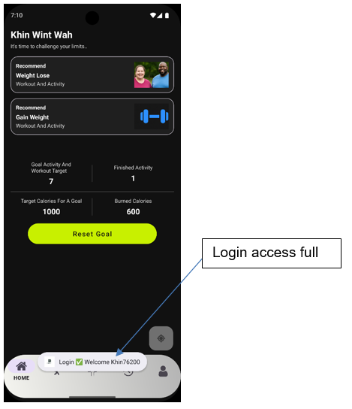

FIGURE-4.33

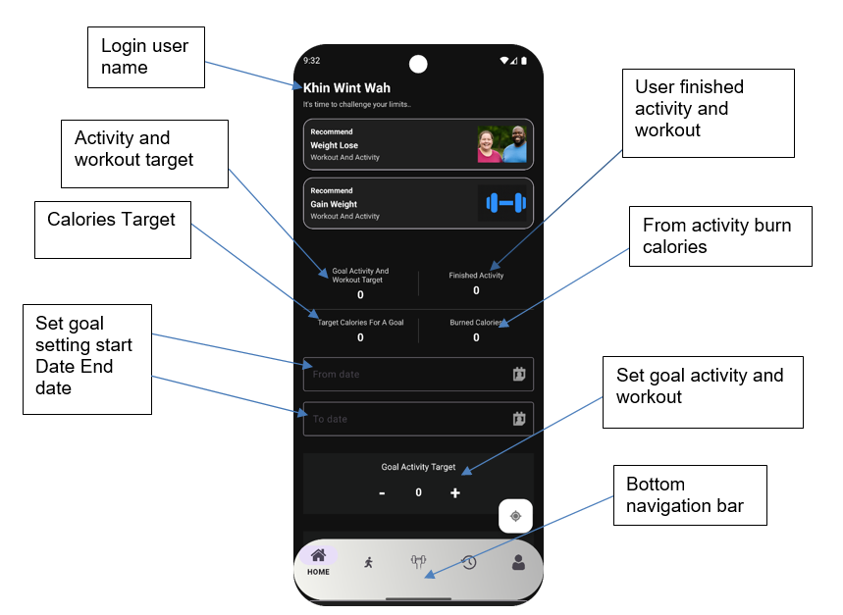

FIGURE-4.34

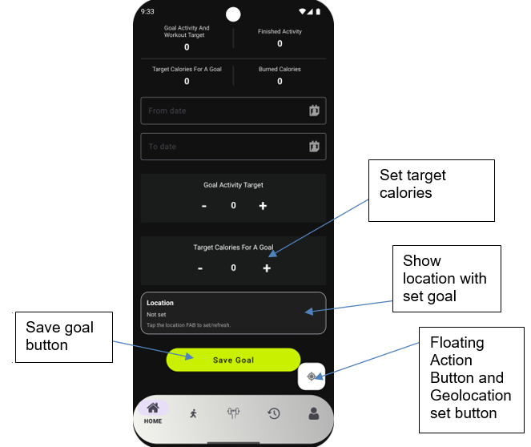

FIGURE-4.35

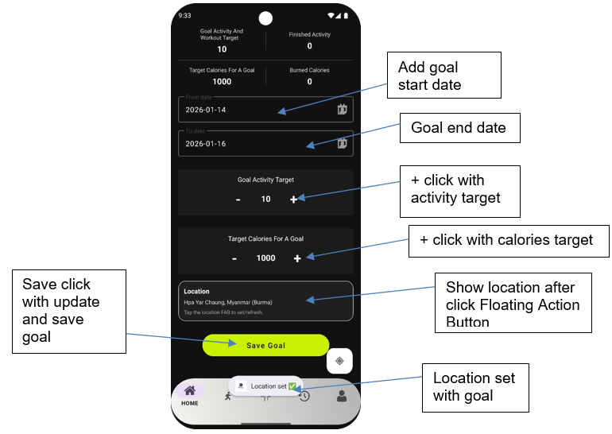

FIGURE-4.36

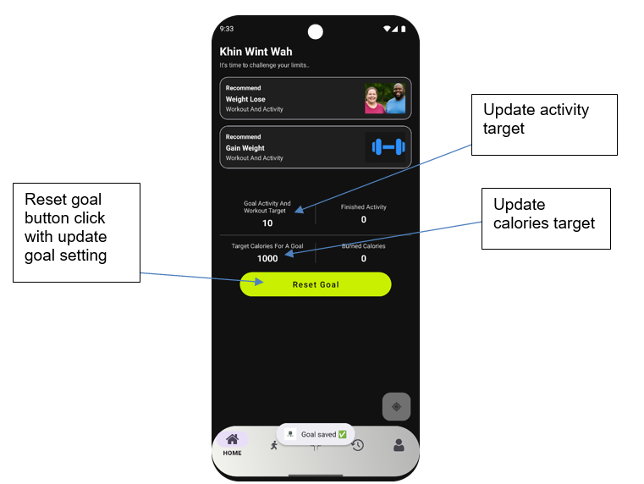

FIGURE-4.37

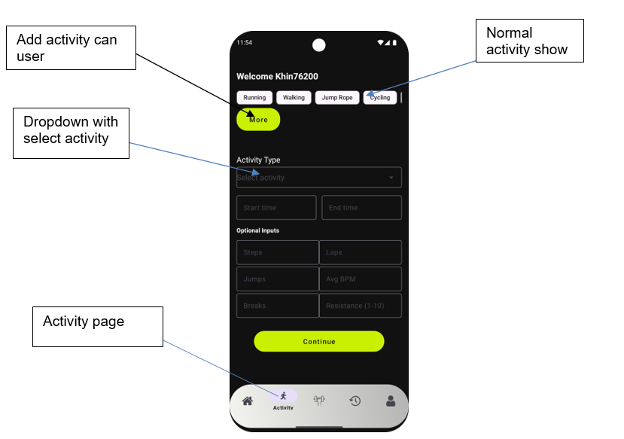

FIGURE-4.38

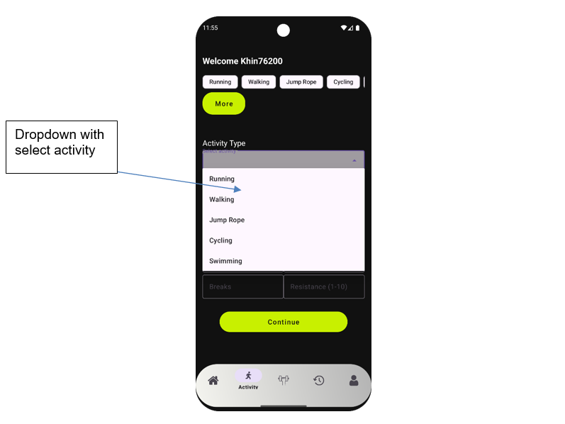

FIGURE-4.39

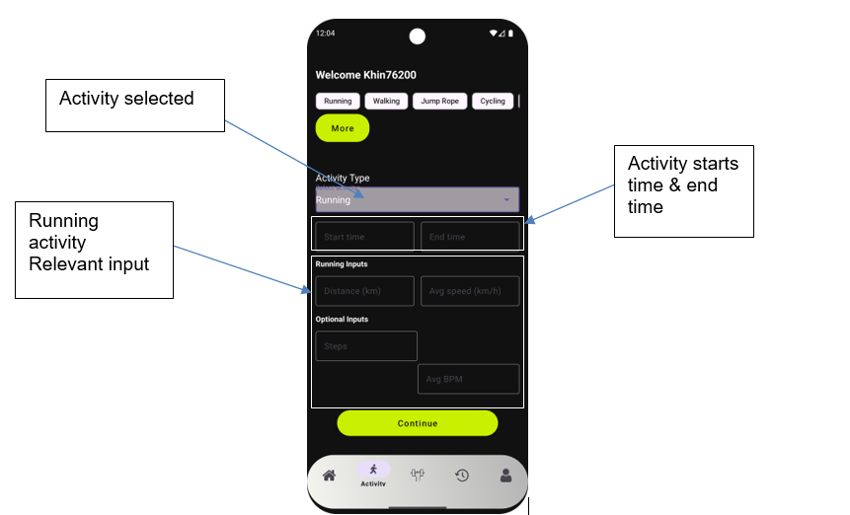

FIGURE-4.40

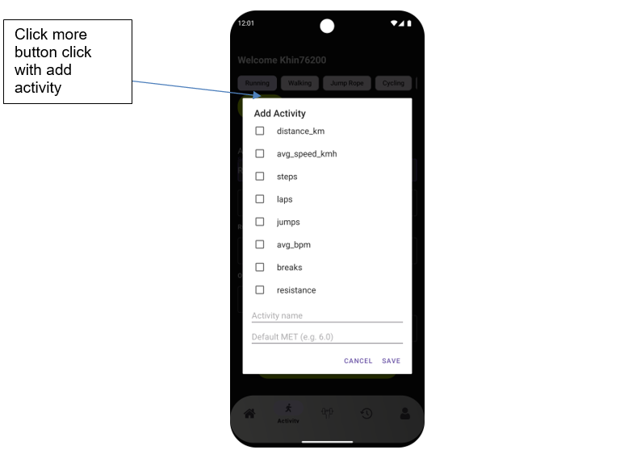

FIGURE-4.41

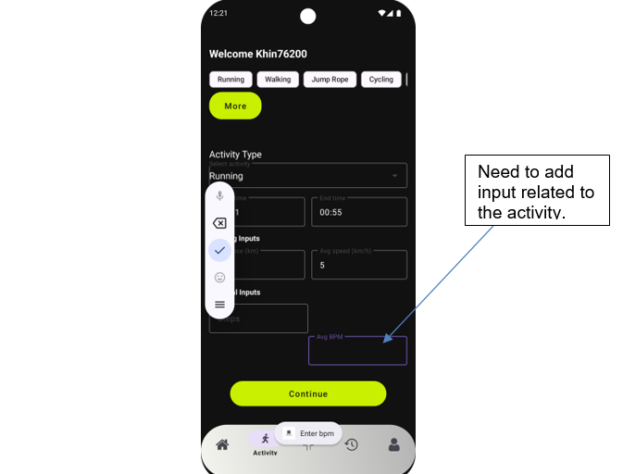

FIGURE-4.42

|  |  |
| --- | --- |
| FIGURE-4.43 | FIGURE-4.44 |

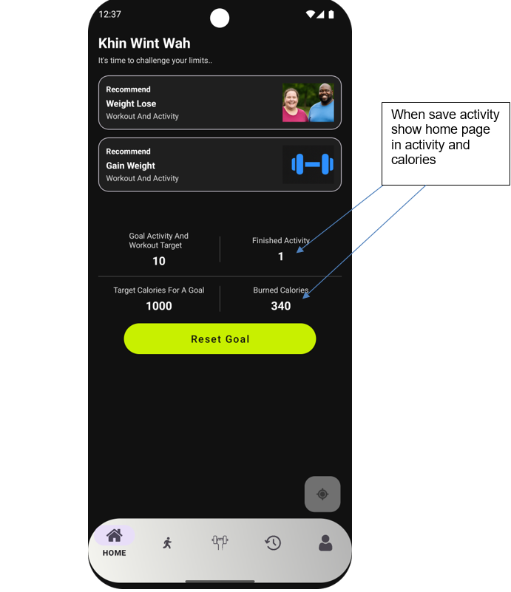

FIGURE-4.45

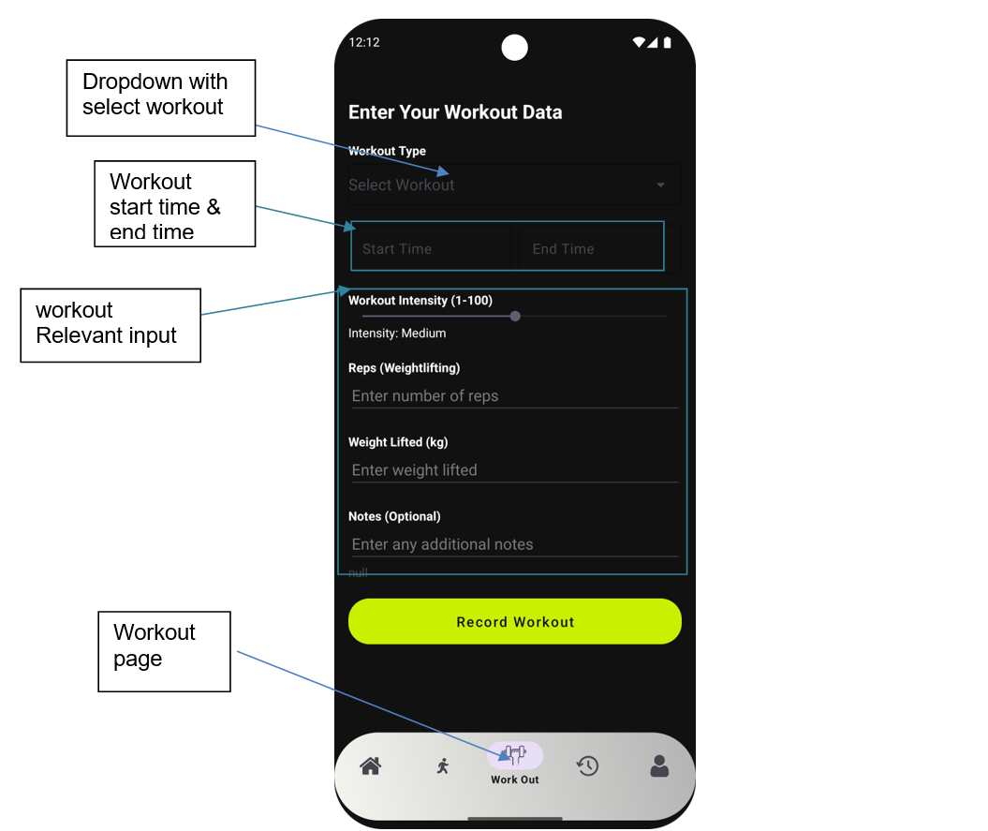

FIGURE-4.46

|  |  |
| --- | --- |
| FIGURE-4.47 | FIGURE-4.48 |
| FIGURE-4.49 | FIGURE-4.50 |

|  |  |
| --- | --- |
| FIGURE-4.51 | FIGURE-4.52 |
| FIGURE-4.53 | FIGURE-4.54 |

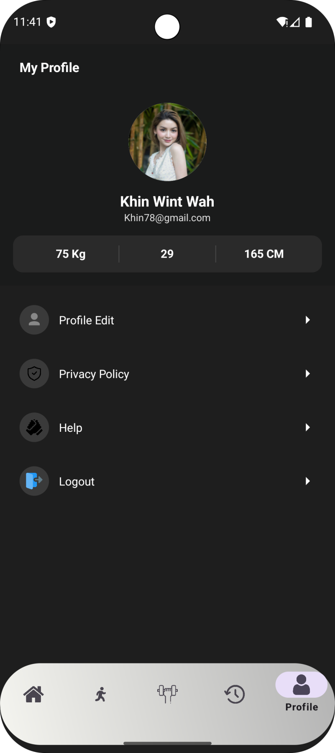

Profile page

FIGURE-4.55

|  |  |
| --- | --- |
| FIGURE-4.56 | FIGURE-4.57 |

|  |  |  |
| --- | --- | --- |
| FIGURE-4.58  Photo update | FIGURE-4.59  Profile data update | FIGURE-4.60  Password update |

|  |  |
| --- | --- |
| FIGURE-4.61  Privacy policy page | FIGURE-4.62  Privacy policy page |

|  |  |
| --- | --- |
| FIGURE-4.63  Help & FAQ page | FIGURE-4.64  Help & FAQ page |

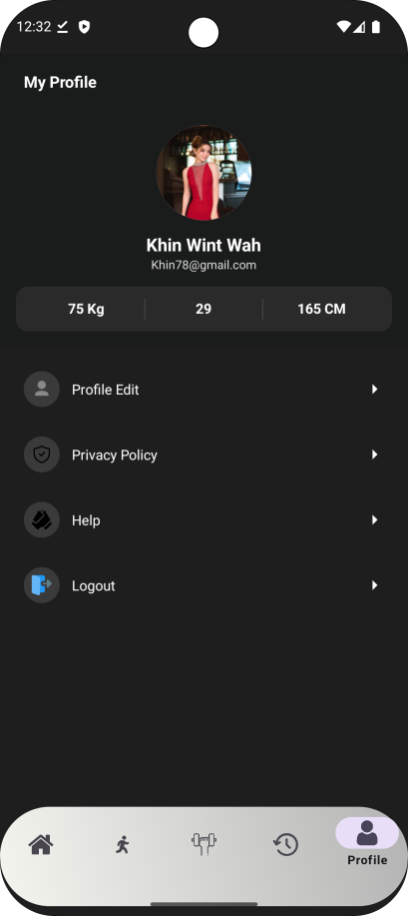

Logout

FIGURE-4.65

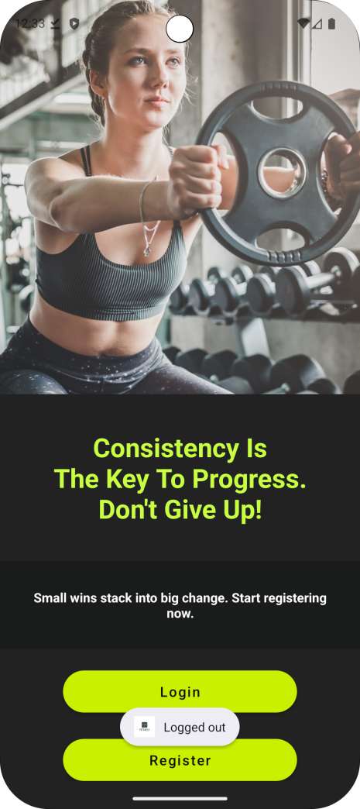

Logout access

FIGURE-4.66

## Database

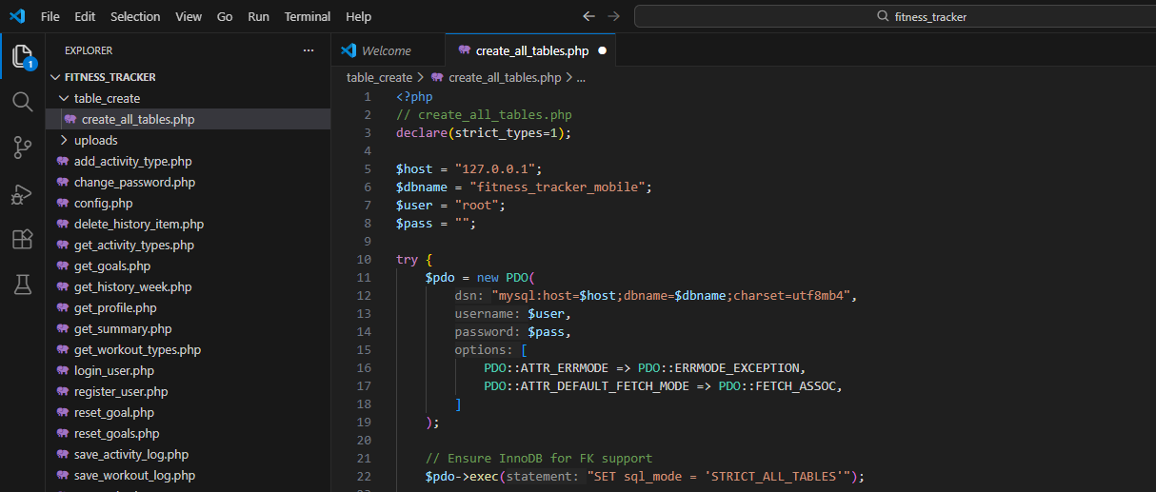

FIGURE-4.67

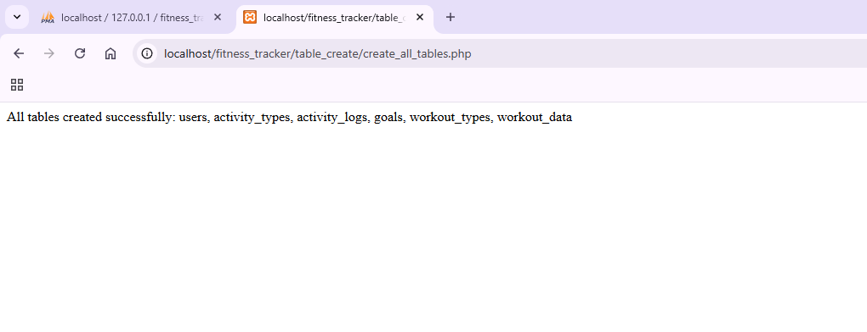FIGURE-4.68

User table create code

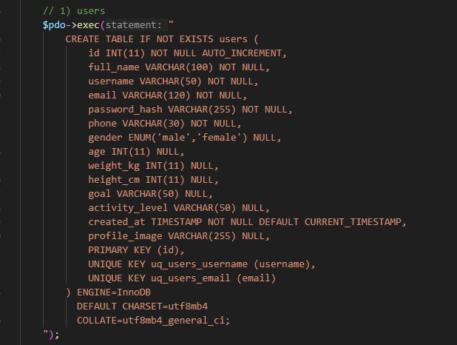

FIGURE-4.69

Database user table

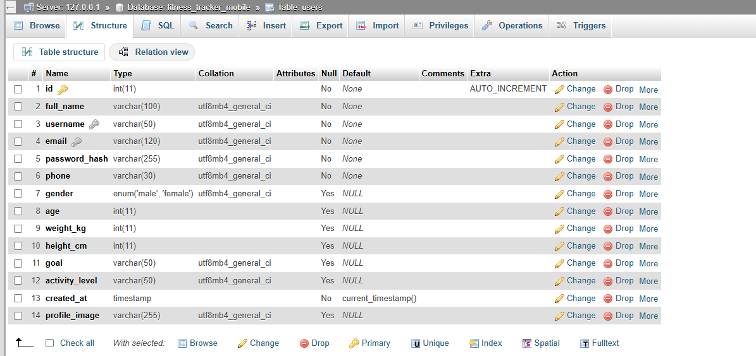

FIGURE-4.70

Insert user and password hash

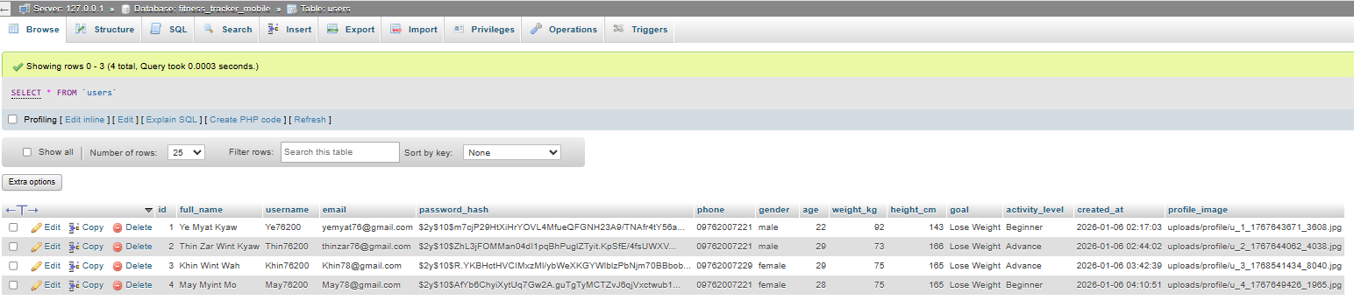

FIGURE-4.71

Activity types table create code

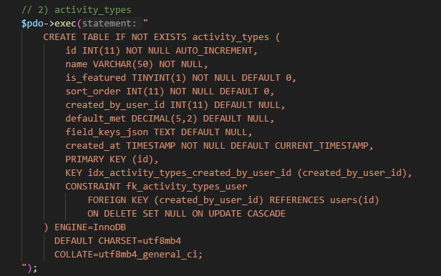

FIGURE-4.72

Database Activity types table

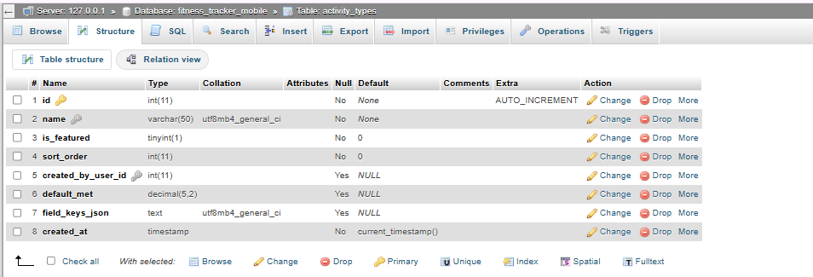

FIGURE-4.73

Insert Activity types table

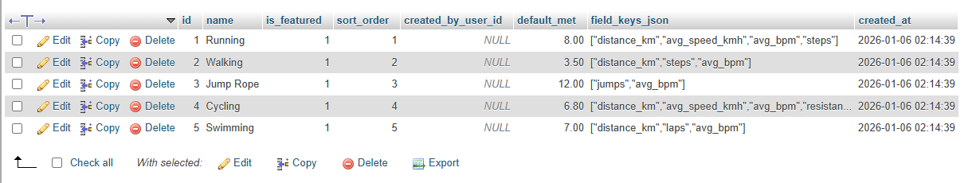

FIGURE-4.74

|  |  |
| --- | --- |
| FIGURE-4.75 | FIGURE-4.76  Activity types table insert |

Activity logs table create code

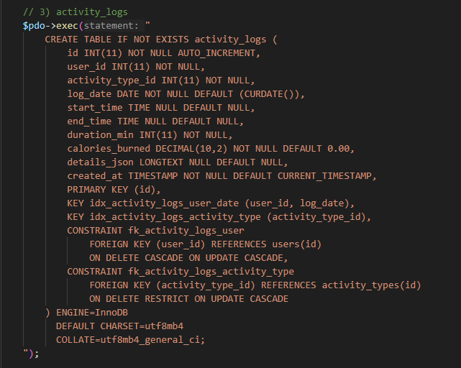

FIGURE-4.77

Database Activity logs table

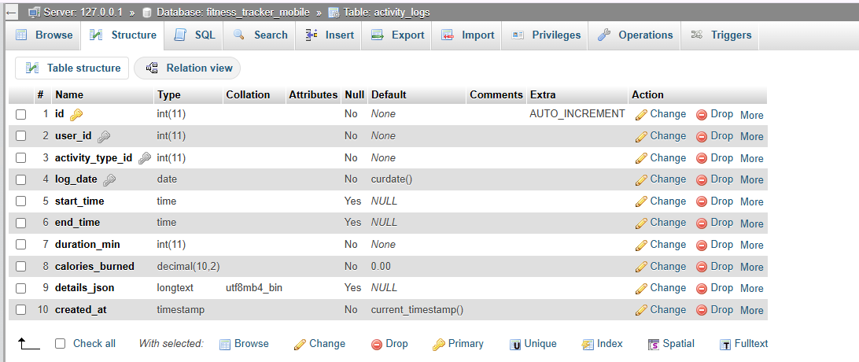

FIGURE-4.78

Insert Activity logs table

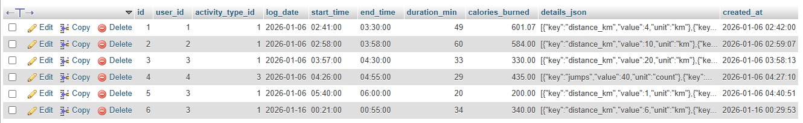

FIGURE-4.79

Goal table create code

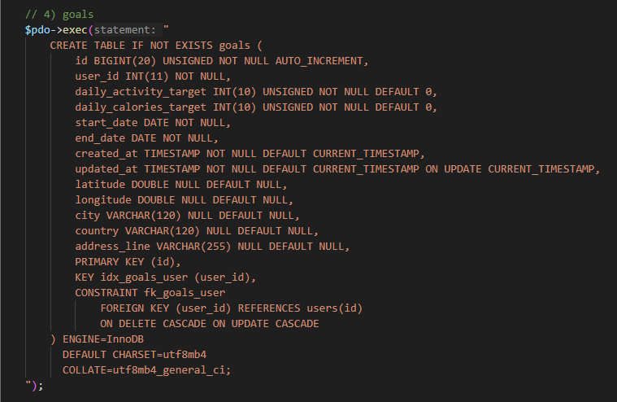

FIGURE-4.80

Database goal table

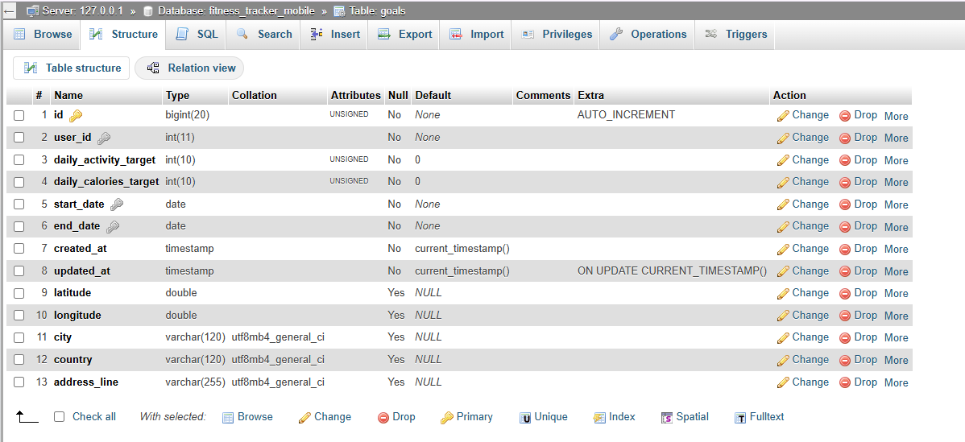

FIGURE-4.81

Insert goal table

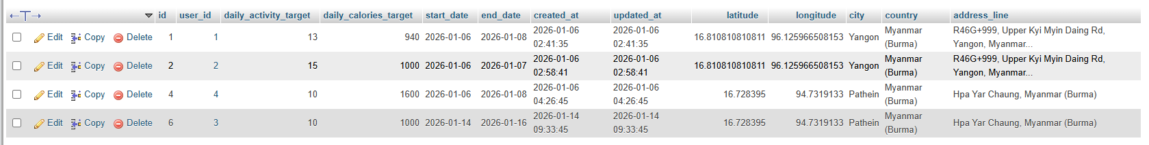

FIGURE-4.82

Workout type table create code

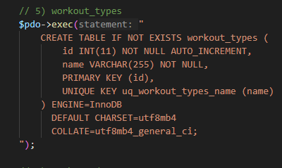

FIGURE-4.83

Workout type table

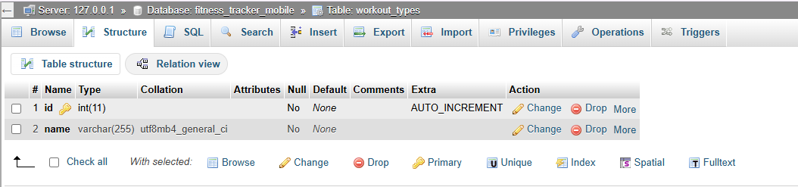

FIGURE-4.84

Insert workout type table

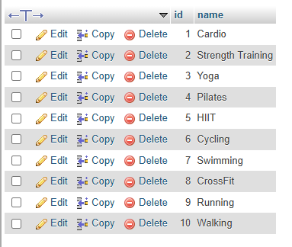

FIGURE-4.85

Workout data table create code

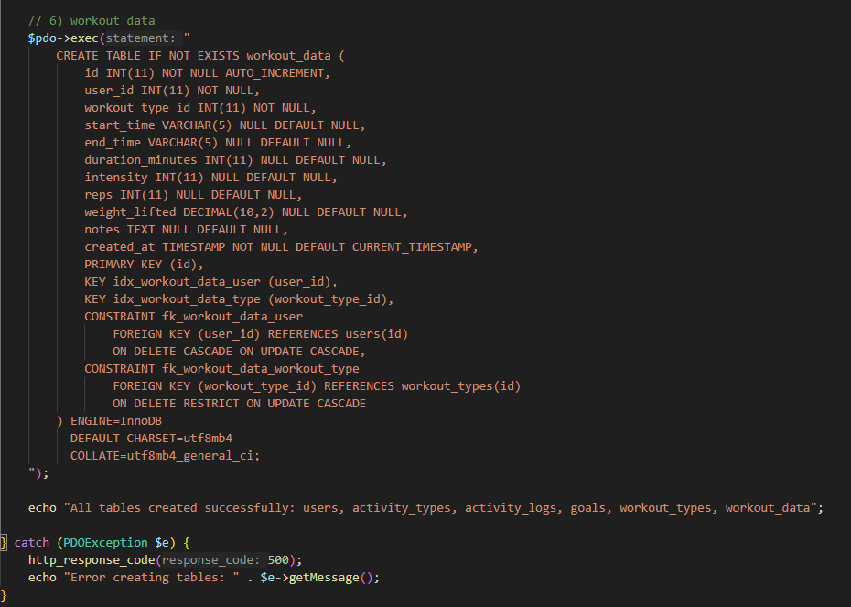

FIGURE-4.86

Workout data table

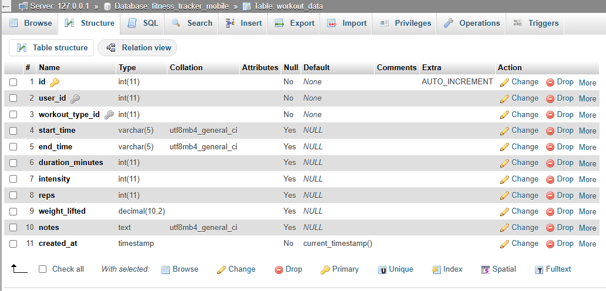

FIGURE-4.87

Insert workout data table

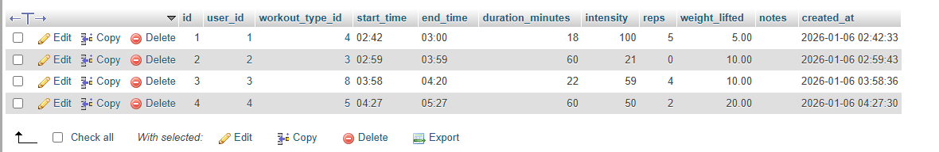

FIGURE-4.88